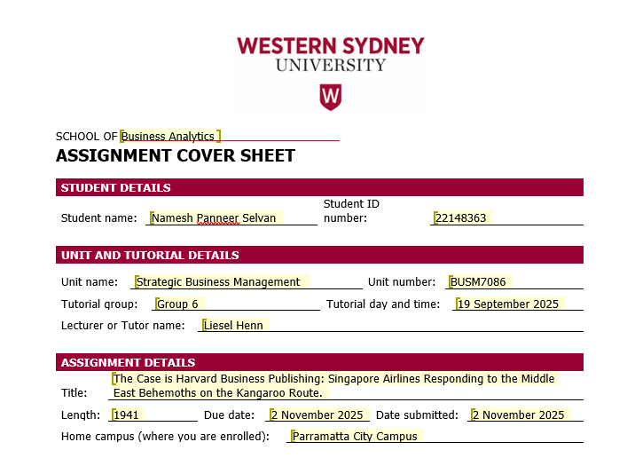
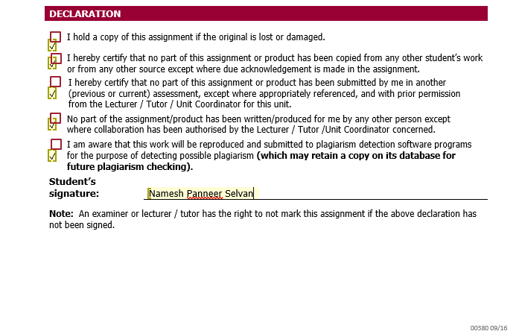

The Case is Harvard Business Publishing: Singapore Airlines Responding to the Middle East Behemoths on the Kangaroo Route.


- Executive Summary:

The report analysis the strategic position of Singapore Airlines (SIA) by identifying the key areas that are impacting the airlines competitive strategy in the global sector. The report runs through the main gaps in their business model and provides a recommendation for the same. With the use of Porter’s five Forces and PEST Framework the report provides a detailed analysis of Singapore Airlines and the areas where they can focus and change their direction towards growth. The study also shares insights on sustainable flying and providing services which are environment friendly with their goal be Net zero in the future.

- Introduction:

Singapore Airlines (SIA) incorporated in 1972 earned a stellar reputation by demonstrating the integration of corporate objectives with its vision and mission to maintain their competitive advantage in the global aviation sector. Their objectives are strategically managed around maintaining elite service quality through operational excellence, network expansion and sustainable financial growth that benefit the shareholders and employees of the company. SIA focuses on providing premium customer service with a judicious financial management. These company objectives are supported by regular investment towards better aircrafts, exceptional in-flight amenities, and broad network connections positioned around Singapore for creating multiple routes for different locations. Being a part of Star Alliance with a motive towards market diversification in multiple sectors like Europe, Australasia and Asia has further aligned its strategic goal of being competitive against their industry rivals ME3 (Emirates, Qatar Airlines & Etihad Airways) (Singapore Management University, 2024).

- Findings (Strategic Gaps are identified): Business Model Findings:

The business model comprises a combination of elite services and wide range of network rooted through Changi, Singapore airport with a partnership alliance and exceptional brand reputation. There are three strategic gaps identified post 2015 market dominance by ME3 and changing passenger preferences (Abdi, Li and Yousefi, 2023).

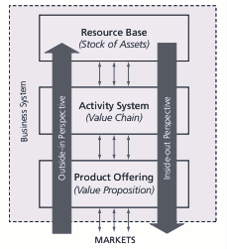
- Resource based gap (capability breadth vs scale):

SIA’s a list of valuable intangible resources like exceptional crew services, brand quality, etc is limited by a smaller operational scope when compared to the current industry giants like ME3 carriers that uses the state provided funds in upgrading their capabilities in terms of increasing the crew members, number of aircrafts that help them deploy their business services at a larger scale and generate more flights for passengers. SIA’s ability to match the level of flight frequency with diverse routs becomes difficult when scale matters (Abdi, Li and Yousefi, 2023).

- Activity-system gap (network & partnerships):

The membership with Star Alliance a centred activity system delivers the value but at a very low rate when compared to that of ME3’s vertically integrated system that helps in commercial partnership and flight scheduling resulting in effective operational outcomes and limiting the slots for their competitors which results in long-haul in one-stop itineraries (Abdi, Li and Yousefi, 2023).

- Product-offering gap (segment coverage and yield management):

While the competition among the elite product differentiation remains strong, the middle market offerings still create the gaps specifically in low-cost and long-haul segment. This leaves the competitors to have the advantage of capturing the price sensitive traffic and scale their yield (Abdi, Li and Yousefi, 2023).

- Findings (Strategic Gaps are identified): External Environment Findings (Porter’s 5 Forces and Industry attractiveness, PEST Analysis):

- What are the major environmental factors impacting the industry?
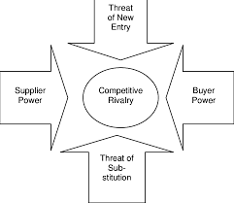
The major environmental factor impacting the industry can explained using the Poter’s force of Competitive Rivalry. In the aviation industry, SIA has a cutthroat rivalry among multiple airlines especially with “ME3” the Middle Eastern carriers like Emirates, Qatar Airways and Etihad Airways. Post 2015, these aviation companies have rapidly grown by leveraging high-capacity aircrafts, providing premium facilities with connectivity to multiple locations, which has highly affected the dominance of SIA in the market. Looking at the situation, it is obvious that SIA is finding it difficult to compete in the current market scope and they should try and shift their focus towards product differentiation (Fan & Lingblad, 2016).
As per the case study on Singapore Airlines SIA’s major hold on the “Kangaroo Route” is being taken over by the ME3 carriers in terms of their global reach and cost model (Singapore Management University, 2024). This clearly explains that competitive rivalry is the major environmental factor impacting SIA’s business model.

- Indicate which industry factors impact the Business Model of the case study company?

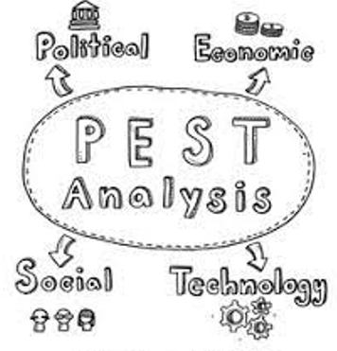
Through PEST analysis we understand that Technological factor was impacting SIA’s business model. Due to lack of technological advancement specifically for long-range aircrafts with more fuel efficiency enabled aircraft carriers like ME3 to come with new hubs and multiple routing patterns on the Europe – Asutralasia sector (Singapore Management University, 2024). This clearly highlights the removal of friction for rivals like ME3 to expand their capacity and have a wider reach over the market. This has also resulted in deteriorating the Singapore hub which was an advantage for SIA.

- Is the industry attractive at the end of the case study? Why? Why not?

Looking at the end period of the case study, it is less attractive for SIA to function as a flag carrier. With the issues over capacity due lack of technological advancement and intense rivalry from the global players would make it difficult for Singapore Airlines to maintain their premium fare rates. Even if there is advancement in these areas it would still be difficult for them to overcome the mounting pressure on yield (Fan & Lingblad, 2016). Additionally, the report on International Airlines in Australia shows a revenue decline of -3.4% CAGR from 2019-24 (IBISWorld, 2025).
Therefore, the case study suggests the competitive environment and cost model pressure while demand exists would make it less attractive for companies like SIA to advance their business.

- Business-Level Strategy Recommendation:

- Strategy Recommendation: - Inside-Out Strategy.

SIA should implement a premium differentiation strategy (Inside-Out Strategy) by reframing its elite service offering and upgrading to high-value routes by partnering with other airlines. The strong brand value with excellent cabin service and having Changi Airport in Singapore as their main hub, it should spin off to a “ultra luxury long-haul carrier”, by narrowing their focus towards premium business and first class and simultaneously improving their route networking for increasing the flight frequency.

- Current strategy Evaluation:

SIA has always followed a differentiation model and sustained an elite level of pricing and service quality (Fan & Lingblad, 2016). However, this has created a disadvantage to scale the business when compared to it market rivals ME3 carriers. Even though SIA remains strong in service, but their scale and network activity system is weaker in the market.

- Strategic gaps in the business:

Business Model | Strategic Gaps
Resource Based | Focusing on elite segments like brand and service quality than improving their route networking and scale.
Activity System | Strengthening selective partnerships with airline companies and joining alliances for premium hub for increasing yield without any massive scale growth.
Product Offering | Protecting margins and brand value by not getting into low-cost middle market and focusing more towards high-yield elite segment.

The recommended inside-out strategy will allow SIA to have sustainable growth and competitive advantage in the next 3 years by focusing more on what it does best with a strategic pocket of limited rivalry.

- Corporate-Level Strategy Recommendation:

- Current Corporate Strategy Evaluation:

As per the financial report for FY25, SIA has registered a strong profitable return of S$2.78 billion and a S$1.09 billion gains from their shares in Air India – Vistara merger. These returns are registered due to their diversified portfolio like Singapore Airlines their elite brand with Scoot handling low-cost aircrafts, a 25.1% of shareholder in Air India group merger and having an SIA Engineering Company reflecting the growing urgency for diversification (Singapore Airlines Ltd., 2025).

- Corporate Level Strategy Recommendation: - Portfolio Strategy.

The corporate level strategy recommendation for SIA is to have a portfolio strategy for their operational ecosystem in their aviation business. The inclusion of Scoot a low-cost operating aircraft to attract the middle market (Singapore Airlines Ltd., 2025). It is identified that there is a huge market potential in the mid segment of aviation industry (IBISWorld, 2025). The alliance with Air India Group can help to elevate their network scale for accessing South Asian countries.

- Maintaining Strategic Edge:

SIA can leverage cost centre synergy by managing their business units in a portfolio strategy structure. Through diversifying their focus towards digital platforms, loyalty programs can reduce their dependency over elite segment of the aviation industry. Through this approach SIA can address their business model gap in resource base, activity system and product offering areas and create a sustainable profit in the global market.

- Corporate Responsibility (ESG):


The 2025 sustainability report of Singapore Airlines illustrates a comprehensive ESG strategy towards its mission of delivering world class flying experience to their customers. SIA has made substantial progress in managing their business with proper environmental care by having 2050 Net Zero road map. Their plan is to invest in next-gen aircrafts which will reduce the carbon emission by 40% and reduce their Sustainable Aviation Fuel (SAF) to 5% by 2030. Along with this airline has a robust board oversight through its Customer Experience, Technology and Sustainability Committee (CETSC), aligning with the UNGC principles. (Singapore Airlines Ltd., 2025).
Based on the recent findings below are the insightful ESG tactics recommended for Singapore Airlines:
- Adaptation of transparent reporting system and have clear ESG KPIs for standardising the process (Caraveo Gomez Llanos, Vijaya & Wicaksono, 2024).
- Having a long-term agreement with suppliers for sustainable Aviation Fuel (SAF) (Kumar, Kumar, Amjad, Kumar & Sassanelli, 2025).
- Digitising their operational platforms for optimising better flight operations (Costas & Romani de Oliveira, 2024).

- Conclusion:

Singapore Airlines (SIA) cements its global reputation by aligning its vision, mission, and operational excellence strategically. The main issues are the fierce competition from ME3 airlines, the limited size of operations, and the changing tastes of the passengers. The SIA management suggests an Inside-Out Business Strategy and Portfolio Corporate Strategy, which together will enhance the situation of SIA utilising their internal excellence and diversifying across different units of their business. Along with their ESG action plan where they have highlighted the use of sustainable fuel, and digital optimization, serve to strengthen the Company's long-term resilience. These strategies put together can help SIA get back in the game with good profits.

- Appendix 1: Business Model (include financial position analysis)

The operations of Singapore Airlines (SIA) are based on a differentiation-based business model which is aligned with its elite customer service, operational excellence and strategic partnership in order to maintain their profitability. Changi Airport in Singapore being the main hub for SIA to connect major flights to global routes by simultaneously deploying elite level of service and brand value (Fan & Lingblad, 2016). Scoot their low-cost aircraft operating in the med market segment enables SIA to have business diversification in the global market.
In 2019-24 the international Aviation in Australia experienced a negative CAGR of -3.4% making the aviation industry most volatile business IBISWorld (2025), still SIA managed to make a sustainable profit via brand value and customer excellence. With growing market competition by their major competitor ME3 the middle east giants were able to over-take the aviation industry (Abdi, Li & Yousefi, 2023).
In the last financial year 2024-25, SIA was able to make record S$19.5 billion revenue and S$2.78 billion net profit, which was majorly supported by the profits received (S$1.09 billion) through their stakes in the Air India Group merger (Singapore Airlines Ltd., 2025). This clearly shows a financial stability can be achieved through diversified business model.

- Appendix 2: Drivers of Industry Development.

- Porter’s Five Forces:

Poter’s Five Forces | Category (High/Moderate/Low) | Analysis
Competitive Rivalry | High | Market shares are affected due to fierce rivalry from their competitors (ME3).
Threat of New Entrants | Low | Regulatory challenges along with the requirement for high capital.
Supplier power | High | Dependence on outsourcing factors such as aircraft, fuel, etc.
Buyer Power | Moderate | Strong brand value and quality customer service created a huge reliability even in volatile market.
Threat of Substitutes | Low | With less alternative to long-haul flights SIA has an advantage.

- PEST Analysis:

PEST | Analysis
Political | Multiple air agreements and aviation regulations with different countries.
Economic | Demand recovery post Covid 19 and increasing fuel cost.
Social | Sustainable travel.
Technological | Reducing operational cost by having advanced aircrafts with fuel efficiency.

Referencing:

Abdi, A, Li, S & Yousefi, M 2023, ‘Global airline competition and the changing dynamics of service differentiation’, Humanities and Social Sciences Communications, Nature, viewed 2 November 2025, https://www.nature.com/articles/s41599-023-01644-8.

Caraveo Gomez Llanos, G, Vijaya, M & Wicaksono, H 2024, ‘Sustainability disclosure and ESG performance in the aviation industry’, Environment, Development and Sustainability, SpringerLink, viewed 2 November 2025, https://link.springer.com/article/10.1007/s10668-023-03775-z.

Costas, A & Romani de Oliveira, G 2024, ‘Trajectory optimisation and carbon reduction strategies in airline operations’, arXiv, viewed 2 November 2025, https://arxiv.org/abs/2412.08783.

Fan, TPC & Lingblad, M 2016, ‘Thinking through the meteoric rise of Middle-East carriers from Singapore Airlines’ vantage point’, Journal of Air Transport Management, ScienceDirect, viewed 2 November 2025, https://www.sciencedirect.com/science/article/pii/S0969699715301058?casa_token=cOTrmliNy4AAAAAA:j0v2rS36jFOChJyaAm8NttfBNSZfNNbqjTHBsu_otUVPBWpF3R6uRE2YmH8Q3IVHsCwjLdsbHg.

IBISWorld 2025, ‘International Airlines in Australia (ANZSIC I4901) — at a glance’, IBISWorld, viewed 2 November 2025, https://my.ibisworld.com/au/en/industry/i4901/at-a-glance.

Singapore Airlines Ltd. 2025, Audited Financial Statements FY2024/25, Singapore Airlines, viewed 2 November 2025, https://www.singaporeair.com/content/dam/sia/web-assets/pdfs/about-us/information-for-investors/financial-results/AuditedFS-fy2425.pdf.

Singapore Airlines Ltd. 2025, Sustainability Report FY2024/25, Singapore Airlines, viewed 2 November 2025, https://www.singaporeair.com/content/dam/sia/web-assets/pdfs/about-us/information-for-investors/annual-report/sustainabilityreport2425.pdf.

Singapore Management University 2024, Singapore Airlines: Responding to the Middle East Behemoths on the Kangaroo Route, case study, viewed 2 November 2025.

